POLYNOMIAL OPERATIONS

Șutea Adrian

Group 30425

Objective
Propose , design and implement a system for polynomial processing . Consider the
polynomials of one variable and integer coefficients .

Analysis
The program will provide a graphical user interface ( GUI ) in which the user can write the polynomials and compute the polynomial operations available . The GUI is made from 3 panels: the label panel, in which the labels for polynomials P1 and P2 are found, the input-output panel, where, the text fields for writting the polynomials and the text field where the result is written, are and the buttons panel, where there arethe buttons for each implemented operation.
The polynomials will be written by the user in a text field for each polynomial. The polynomials should as a sum of monomials like aX^b, where a is the coefficient and b is the power of X. A constraint for the input is that for a polynomial of degree n, all the n monomials have to be written, even if their coefficient or power is zero. The result of the operation will be also displayed in a text field . The operations are selected with the buttons for each available operation .

2.1. Classes analysis
A total of five classes are in the program separated in two packages : gui and poly. The package gui only contains the class Gui, while the package poly contains : a class for monomials, a class for polynomials, a class for the operations and the main class.
Package poly : Monomial : has as attributes the coefficent of x, which can be of type Integer or Double, the power of x and getters and setters for each of the contained attributes
Polynomial : is constructed as an ArrayList of Monomials, as an attribute it has the degree, it also has methods for adding and removing a monomial from the ArrayList and also contains a getter and a setter for the degree.
Operations : this class contains all the operations that can be performed on the given polynomials. These operations are: addition, subtraction, multpilication, division (doesn’t work), integration and derivation.
Main : this only contains an instance of the Gui class.

Package gui :
Gui : this class constructs the user interface, adds buttons, text fields and labels to panels and adds ActionListeners to each button. It also contains the methods which transform a string into a polynomial and vice versa and the methods which get the text from the text field and transform into a polynomial.

2.2. Scenarios
When the user gives the polynomials : P1 = 2x³ + x² + x + 5 and P2 = 3x³ – 2x² + x – 6 ( written in the form : 2x^3 + 1x^2 + 1x^1 + 5x^0 and 3x^3 - 2x^2 + 1x^1 - 6x^0 ) each polynomial is parsed . Each found integer is counted in a counter. If the value of the counter is an even number then a new Monomial is created and the integer is stored as it’s coefficient and the monomial is added to the polynomial. If the value of the counter is an odd number, it is set as the power for that monomial. When the counter has the value of 1, the integer which was found is set as the degree of the polynomial. After an operation is performed, the resulting polynomial is transformed back to a string and then it is added to the text field of the result.
The results of each operation are : addition -> 5x^3 - 1x^2 + 2x^1 – 1x^0 , subtraction -> -1x^3 + 3x^2 + 11x^0 , multiplication -> 6x^6 - 1x^5 + 3x^4 + 2x^3 - 15x^2 - 1x^1 – 30x^0, division: en error ☺ , derivation of the first polynomial -> 6x^2 + 2x^1 + 1x^0 , integration of the first polynomial -> 1.0x^4 - 1.0x^3 + 1.0x^2 – 6.0x^1.

Design
The program has four classes: Polynomial , RealPolynomial , GUI and Main. The polynomial class contains most of the operation on polynomials , the RealPolynomial class extends the Polynomial class , allowing real coefficient to be used in the integration operation , the GUI class constructs the user interface and the action listeners , and the Main class creates the GUI .

3.1. Classes
The Polynomial class contains the attributes , the constructor for the Polynomial type objects , the getters and setters and all the operations except integration . The class also contains the overridden „toString” and „equals” methods.
The RealPolynomial class extends the Polynomial class and it is used for the integration operation as it allows for real values for coefficients . The class has the same attributes as the Polynomial class , a constructor, getters and setters, a method to compute the integration of a polynomial and also the „toString” method.
The GUI class implements the graphical user inteface which allows the user to insert the polynomials and the value of x in case of the evaluation operation, and to see the outut of the operations . The class consists of the GUI constructor and the action listeners.
The main class, which creates the GUI.

3.2. UML Diagrams
3.2.1. UML Class Diagram
The class diagram with the relationships between classes is shown below .
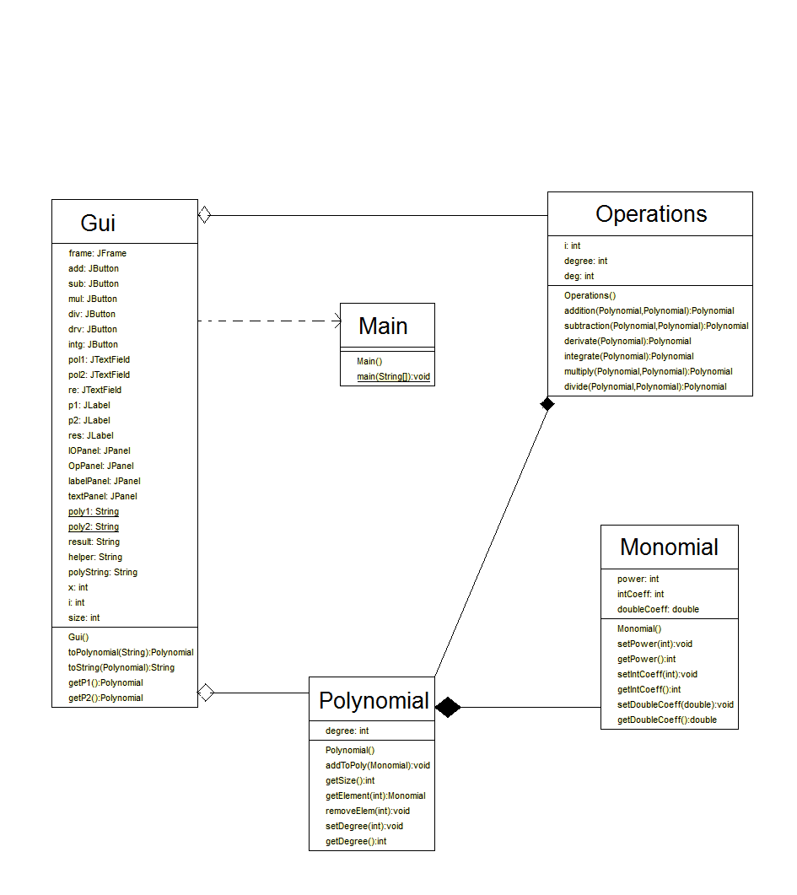

3.2.2 UML Use-Case Diagram
The use-case diagram shows the user interacting with the application. He can perform on the polynomials several operations like: addition, subtraction, multiplication, division, integration and derivation.

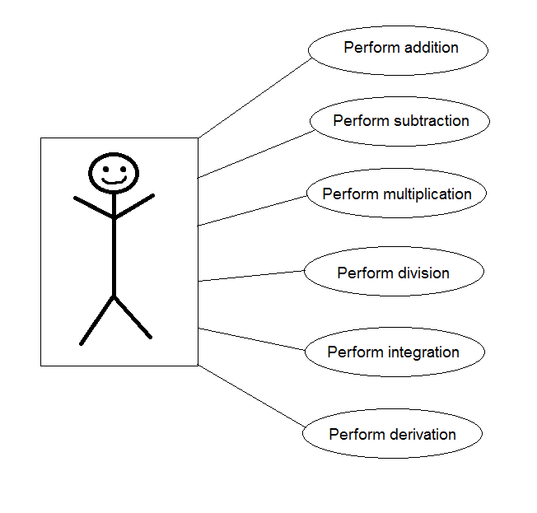

3.3. Relationships between classes

As seen on the class diagram above there are many types of relationships between the classes of this program . The most important ones are the composition relationship between the Monomial class and the Polynomial class and the composition relationship between the Polynomial class and the Operations class. The user interface can be shown only if an instance of class Gui is created, therefore between the Gui class and the Main class there is a dependency relationship, because the Gui couldn’t exist whithout it being instantiated in the main class. Because the class Gui has instances of the Polynomial class, an aggregation relationship is found between them, same relationship takes place between the Operation class and the Gui class.

Implementation

4.1. Implementation and testing
In what the implementation is concerned this project was developed in Eclipse and it was only tested in this environment. However the program should maintain its portability. Concerning the code implementation I did not make use of laborious algorithms, but I have rather stayed faithful to the classical algorithms of computing polynomials learned in high school. However I have tried to implement my problem in a way that appears to me as being the most efficient one, that is why I have changed my model at first. On the subject of this I have decided to use ArrayList instead of arrays because I believe that they are more efficient related to performance and memory management.
Testing implies checking for any errors in the program or limitations of this program. Due to the fact that the program is rather simplistic, they are few errors that might generate this program to work wrong or to stop. This errors are mostly related to the interface. I have assumed that the user reads the instructions from the interface and respects them, otherwise if he enters data with invalid format the program will probably generate some bugs and will stop. Hence this part with checking all the possible scenarios will be seen as future development.

4.2. Implementation details

The Monomial class :
- A polynomial has three attributes: an integer Coefficient, a double coefficient and the power.
- The methods setPower and getPower are setter and getter for the power
- The methods setIntCoefficient and getIntCoefficient are setter and getter for the integer coefficient
- The methods setDoubleCoeff and getDoubleCoeff are setter and getter for the double coefficient

The Polynomial class :
- A polynomial has two attributes : the degree and an ArrayList of monomials. The degree stores the order of the polynomial and ArrayList stores each monomial that is contained in the polynomial.
- The constructor has no parameters : the only thing that it does is creating a new ArrayList of monomials .
- The getSize method returns the size of the ArrayList.
- The addToPoly method adds the Monomial „m” , got as parameter , to the polynomial.
- The getElement method returns the Monomial from the ArrayList found at the index received as parameter.
- The removeElem method removes the element from the ArrayList found at the index received as parameter .
- The setDegree and getDegree methods are setter and getter for the degree of the polynomial.
The Operations class :
- The Operations class has as attributes a polynomial, some monomials and some other variables .
- The addition method returns a polynomial which is the result of adding the two polynomials, P1 and P2 , received as parameters. The first thing that is done in order to perform the addition is to create a new instance P of a Polynomial which will be used for storing the result. Then, the method checks which one of the polynomials P1 and P2 has a higher degree and sets the higher degree as the degree of the result polynomial P. After that, a for loop passes through all the monomials of the polynomial with the higher degree and compares the power of each monomial from the two polynomials and if it is equal then it adds to a new monomial as coefficent, the addition of the coefficients of the two monomials, and as power the power of either one of the monomials. The newly created monomial is then added to the polynomial P.
- The subtraction method returns a polynomial which is the result of subtracting the first polynomial got as parameter from the second one. This method works in the same way as the addition method, the only difference between them is the fact that , when two monomials with the same power are found then, for addition it adds the coefficients and then adds them to a new monomial, and for subtraction, it subtracts the first one from the second one and then adds them to the monomial. After that for both methods, the new monomial is added to the polynomial.
- The multiplication method returns a polynomial which is the result of multiplying the two polynomials, P1 and P2, received as parameters. The method starts by creating an instance P of a Polynomial and also an instance Partial of a polynomial and sets the degree of P and Partial to the sum of the degrees of polynomials P1 and P2. By using two for loops, the method passes through each element of each polynomial. At each pass, a new monomial is created and it’s coefficent is set as the coefficient of the monomial from P1 multiplied by the coefficent of the monomial from P2 and it’s power is set as the power of the monomial from P1 added to the power of the monomial from P2. The newly created monomial is added to the polynomial Partial. After all elements have been looped through, the polynomial Partial contains the result, however it may also contain monomials which have the same power which should be added, so that’s not quite correct. In order to add the monomials with the same power the method has 2 for loops: one in which an „i” starts from 0 to the size of the ArrayList of the polynomial Partial and one that starts from „i+1” to the size of the ArrayList of the polynomial Partial. In this way, everytime two elements with the same power are found, a new monomial is created and it’s coefficent will be the sum of the coefficients of the monomials with equal powers. After exiting the second for loop, the newly created monomial is added to the polynomial P.
- The integration method returns a polynomial which is the result of integrating the polynomial P1 received as parameter. This method starts by creating an instance P of a Polynomial and setting the degree of P to the degree of P1 + 1. After that a for loop passes through all the elements of P1, at each pass it creates a new monomial. The new monomial gets as coefficient the coefficient of the monomial from P1 divided by the power of the monomial from P1 + 1, if the power from the monomial from P1 is different from 0, and as power the power of the monomial from P1 + 1, then the monomial is added to the polynomial.
- The derivation method returns a polynomial which is the result of derivating the polynomial P1 received as parameter. The method starts by creating an instance P of a polynomial and setting the degree of P to the degree of P1 – 1. After that a for loop passes through all the elements of P1, at each pass it creates a new monomial. The new monomial gets as coefficent the power of the monomial from P1 multiplied by the power of the monomial from P1, if the power is different from 0, and as power it sets the power of the monomial from P1 subtracted by 1, then the monomial is added to the polynomial.
The Main class :
- The main class has only a method (main) and a single instruction that creates a new GUI.

The Gui class :
- The Gui contains declarations of all the panels , buttons , labels , and text fields and also some strings for getting what was written in the text fields, and an instance of a Polynomial .
- The user interface is structured in the following way: a frame which has 2 panels. In the constructor the size of the frame is set to 1024 x 480, the frame is set visible and also the frame’s default close operation is set. The 2 panels containedby the frame are the IOPanel, which also contains another two panels: the labelPanel and the textPanel, and the OpPanel.The textPanel contains the 3 text fields, for: the first polynomial, the second polynomial and for the result. The labelPanel contains the labels shown in front of each text field field form the textPanel. The OpPanel contains the buttons for each operation.
- To each button has been added a ActionListener. The structure of the triggered ActionEvent method for each button is similar: depending on the button that was pushed, a polynomial gets the result of the asked operation, then the polynomial is transformed into a string and then the string is set as text to the result text field.
- The method toPolynomial returns a polynomial created from the string given as parameter. The method uses a Matcher and a Pattern to find the integers in the given string. The pattern used is : (“[\\+-]?\\d+”). By using this pattern, the matcher searches for integers, even if they are positive or negative. After declaring a Matcher and a Pattern, the method enters a while loop that has as condition (mat.find()==true), which means that it will continue looping while the matcher finds another integer. When an integer is found it is actually returned by the matcher as a string, so in order to convert it into an integer, the method uses Integer.parseInt . The number of integers found is counted by a counter that starts from 0. If the counter has an even value, then a new monomial is created and it’s coefficient is set as the found integer, if the counter has an odd value, then the power of the monomial is set as the found integer and the monomial is added to the polynomial. When the value of the counter is 1 then the value of the found integer is set as the degree of the polynomial.
- The method toString returns a string created from the polynomial received as a parameter. The method starts by creating a new string polyString in which the result will be saved. The method uses a for loop in order to pass through all the elements of the polynomial, for each pass the string polyString is updated. If the coefficient is bigger than 1, then to the polyString will be added a „+” sign followed by the coefficient then „x^” and then the power. If the coefficient is smaller than 0 then to the polyString will be added the coefficient followed by „x^” and then the power. If the coefficient is 0, then it won’t be added to the string. The same things are done for the integer coefficients and for the double coefficients.
- The method getP1 gets the string found in the text field for the polynomial P1 and by using the method toPolynomial, transforms it into a polynomial and returns the polynomial.
- The method getP2 gets the string found in the text field for the polynomial P2 and by using the method toPolynomial, transforms it into a polynomial and returns the polynomial.

Conclusions
The things that must be considered when implementing such an application is the way the polynomial are given by the user and how the objects are created from the user input . Also, the division by zero has to be avoided in order to have a good implemetation. The hardest part of this project was the implementing the division of the polynomials because it needed recursive calls and the algorithm was much more complicated than the ones for the other operations. Another tricky thing was to get the integers from the strings written in the polynomials text fields. What I learned from this project is that you should always write small parts of code and test them before continuing with the rest of the development.

Bibliography

http://stackoverflow.com/questions/1986031/how-to-use-pattern-matcher-in-java - from here I learned how to use the Matcher and the Pattern for getting the integers out of the string
http://creately.com/blog/diagrams/class-diagram-relationships/ - from here I learned how to construct a class diagram
http://www.javatpoint.com/java-swing - from here I learned how to use Swing utilities and also how to use action listeners.

